**Experiment -1.1**

**Student Name: Agamjyot Singh Maan UID: 22BDO10049**

**Branch: CSE(DEVOPS) Section/Group:22BCD-1/A**

**Semester: 4TH Date of Performance: 17/01/2023**

**Subject Name: GIT AND GITHUB Subject Code: 22CSH-293**

**1. Aim/Overview of the practical:**. Install Git and creating repository

**2. Software used:** GitHub and Git Bash .

**3. Hardware Used:** PC.

**4. Steps for experiment:**

**For Installation of Git :**

**1.** Download Git for windows from chrome.

**2.**  Click on windows and go for 64 bit installer.



**3.** Click on install

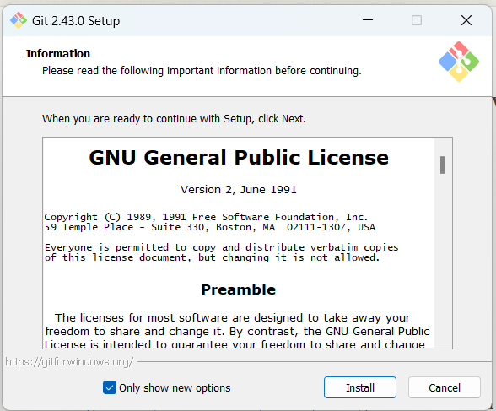

**4.** Select the location for installation for the git.

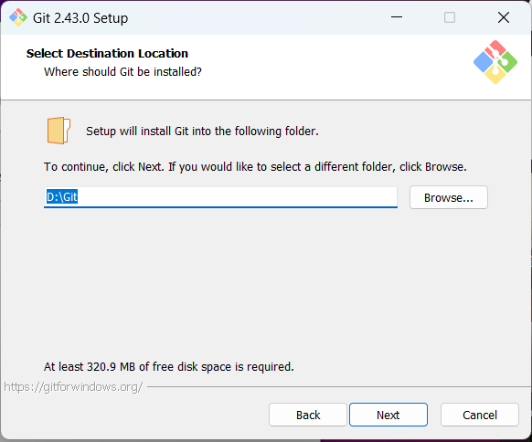

**5.** Click on next for all default settings.

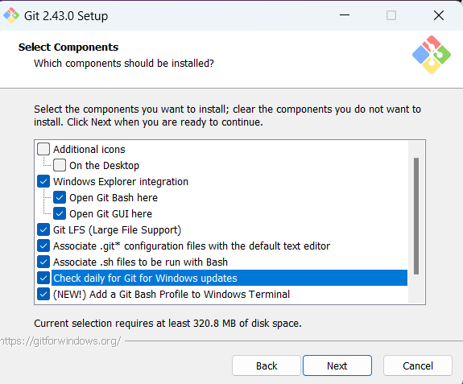 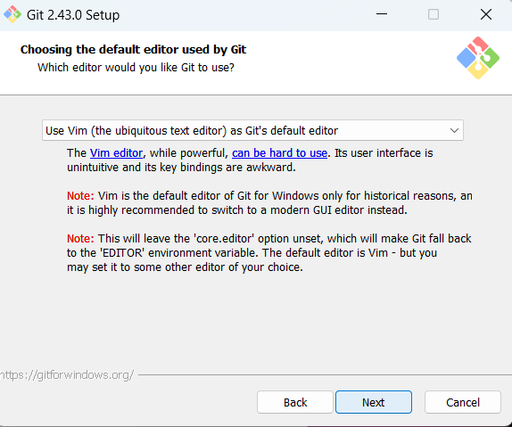

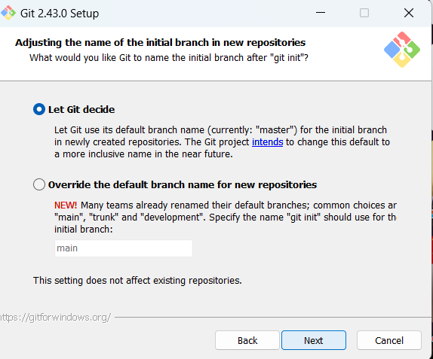 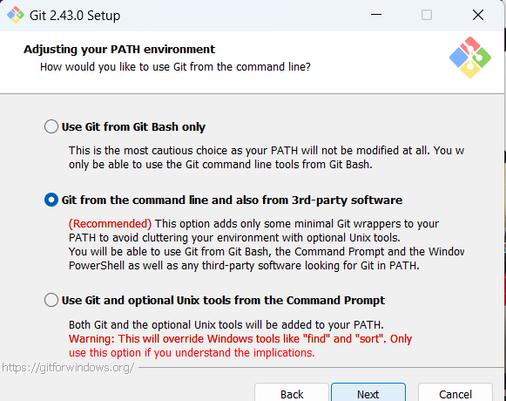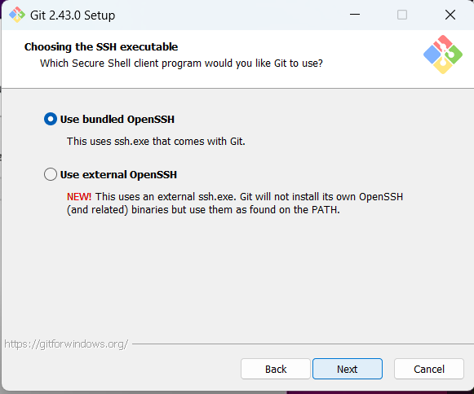 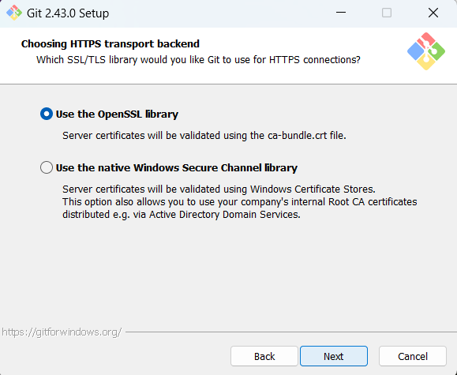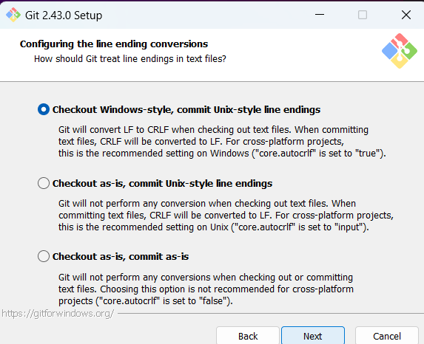 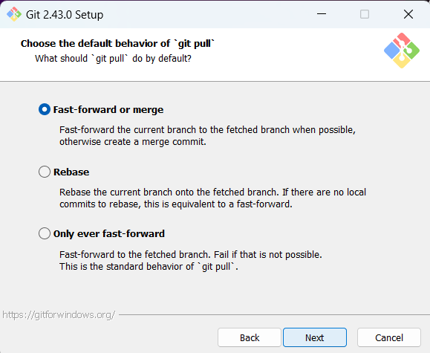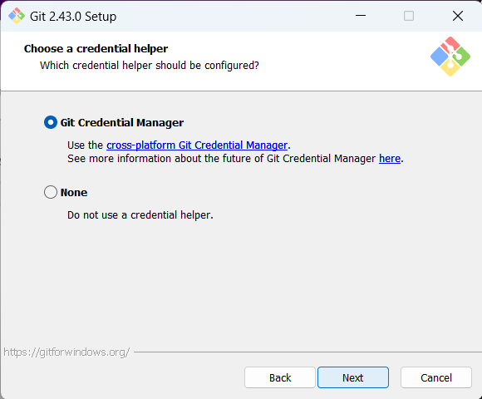 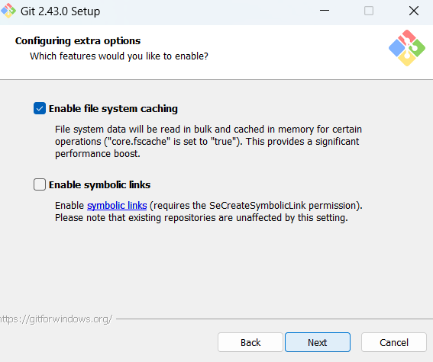

**6.** Click on Finish after successful completing the installation.

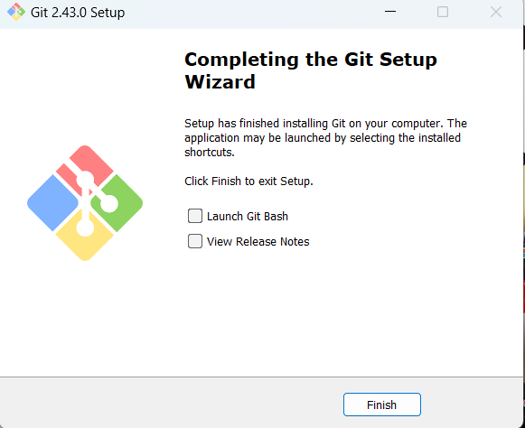

**7.** To verify whether git is installed in the system or not follow these steps.

Go to CMD then type *“git”*

It will give a version and description of Git

**Creation Of an Account on GitHub**

Follow these steps to create an account on GitHub

1. Type GitHub on google.
2. Go for signup.
3. Login with email.
4. Give a password.
5. Accept the condition and fill information.
6. After completion, the profile page will look like

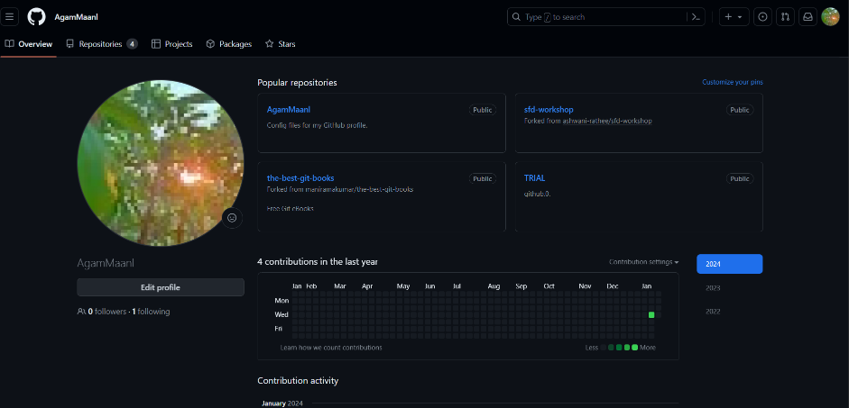

**Creating a repository on GitHub**

1. Goto GitHub account2. Then Repositories3. Click New and write the name of the repository and description (optional) and Public (to access openly)4. Add a README file (Details of Project)5. Add .gitignore6. License (none)7.Click "Create Repository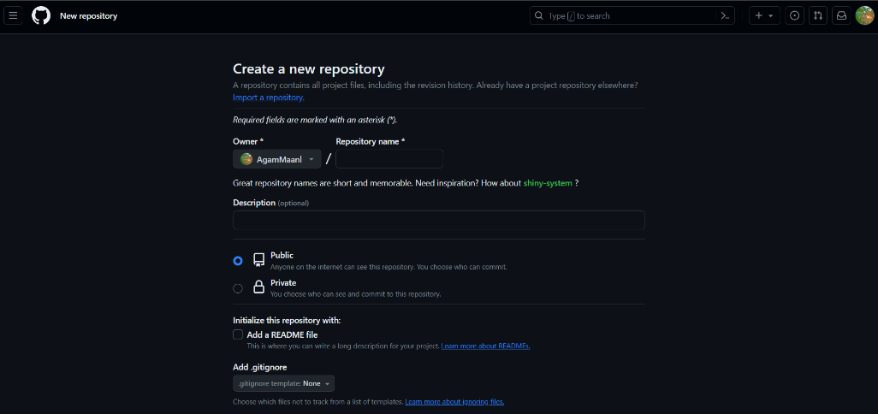

**Configuration of Git And Github:**

To configure Git and Github we have to write some commands in Git Bash which we enlist our username and email in Git.

**Steps: For username**

Type code:- *git config --global user.name “*AgamMaan1*”*

**For Email**

Type code:- *git config --global user.email* agammaan3332gmail.com

**To verify**

Type code:-*git config --list*

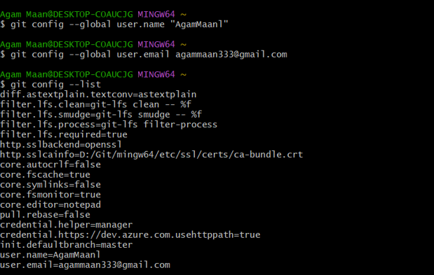

**For cloning the repository:**

Use Command

*git clone* [*https://github.com/AgamMaan1/Git_Hub.git*](https://github.com/AgamMaan1/Git_Hub.git)

Press enter.

**Some useful command**

cd- Change the directory

touch- it is used to create file.

ls- used to print no of files in repository.

pwd- used to print the current working directory.

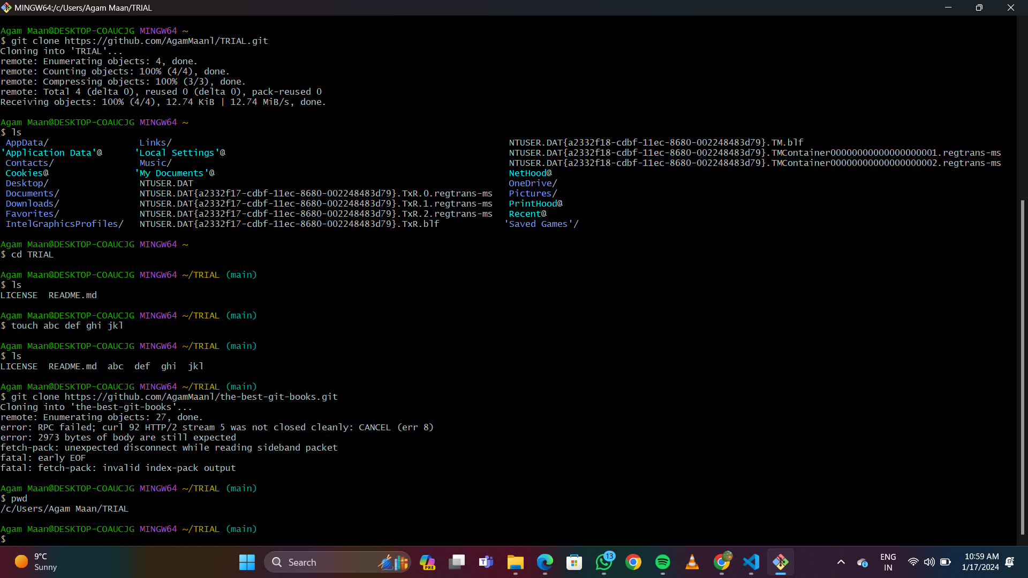

**5. Result/Output/Writing Summary:**

During this experiment, we initiated the installation of Git, set it up by linking it to our GitHub account, and executed various commands such as clone to retrieve a remote repository onto our local machine. Additionally, we utilized commands like cd, touch, ls, and pwd.

**Learning outcomes (What I have learnt):**

1. Learnt how to perform Git installation.
2. Learnt about configuring of Git with a GitHub account.
3. Learnt about basic commands like cd and cat.
4. Learnt about git clone for repository retrieval.
5. Learnt adding and committing updates to the GitHub account.

**Evaluation Grid (To be created as per the SOP and Assessment guidelines by the faculty):**

|  |  |  |  |
| --- | --- | --- | --- |
| Sr. No. | Parameters | Marks Obtained | Maximum Marks |
| 1. |  |  |  |
| 2. |  |  |  |
| 3. |  |  |  |
|  |  |  |  |